Software Requirements Specification
for
Weather-Based Crop Advisory System
Version 1.0
Prepared by Project Author
Academic Project Documentation
10-Sep-2026

Table of Contents
Revision History iii
1. Introduction 1
1.1 Purpose 1
1.2 Document Conventions 1
1.3 Intended Audience and Reading Suggestions 1
1.4 Product Scope 1
1.5 References 1
2. Overall Description 1
2.1 Product Perspective 1
2.2 Product Functions 1
2.3 User Classes and Characteristics 1
2.4 Operating Environment 2
2.5 Design and Implementation Constraints 2
2.6 User Documentation 2
2.7 Assumptions and Dependencies 2
3. External Interface Requirements 2
3.1 User Interfaces 2
3.2 Hardware Interfaces 2
3.3 Software Interfaces 2
3.4 Communications Interfaces 2
4. System Features 3
4.1 User Authentication 3
4.2 Weather and Location 3
4.3 Crop Advisory 3
4.4 Administration 4
5. Other Nonfunctional Requirements 4
5.1 Performance Requirements 4
5.2 Safety Requirements 4
5.3 Security Requirements 4
5.4 Software Quality Attributes 4
5.5 Business Rules 5
6. Other Requirements 5
Appendix A: Glossary 5
Appendix B: Analysis Models 6
Appendix C: To Be Determined List 7

Revision History
Name | Date | Reason For Changes | Version
Project Author | 10-Sep-2026 | Initial SRS for academic submission. | 1.0

1. Introduction
1.1 Purpose
This Software Requirements Specification defines the requirements for the Weather-Based Crop Advisory System. It describes the system scope, users, interfaces, functional features, nonfunctional requirements, business rules and analysis models.
1.2 Document Conventions
The section numbering and organization follow the supplied SRS template. The word “shall” indicates a mandatory requirement. Functional requirements use unique identifiers for traceability.
1.3 Intended Audience and Reading Suggestions
This document is intended for the project developer, tester, evaluator, teacher and end user. Sections 1–2 give an overview; Sections 3–5 provide implementation and testing requirements; Appendix B contains the analysis models.
1.4 Product Scope
The system uses a selected farming location, crop information and weather data to generate understandable crop-specific recommendations. It supports decisions such as irrigation timing, spraying decisions and weather-related alerts. It is a decision-support tool and does not guarantee agricultural outcomes.
1.5 References
The section structure follows the supplied Software Requirements Specification template, including Introduction, Overall Description, External Interface Requirements, System Features, Other Nonfunctional Requirements, Other Requirements and Appendices.
2. Overall Description
2.1 Product Perspective
The application receives weather information from an external weather service and combines it with crop information and configured advisory rules. The main flow is Farmer → Application → Weather Service → Advisory Engine → Farmer.
2.2 Product Functions
Registration/login; location selection; crop and crop-stage selection; weather retrieval; advisory-rule evaluation; crop-specific recommendations; alerts; and administrator management of crops and rules.
2.3 User Classes and Characteristics
User Class | Characteristics
Farmer | Primary user; needs a simple interface and understandable recommendations.
Administrator | Privileged user who maintains crop information and advisory rules.

2.4 Operating Environment
A modern web browser on desktop, tablet or smartphone; application server; database; and network access for live weather data.
2.5 Design and Implementation Constraints
External weather-service availability/rate limits, changing forecasts, secure API credentials, and the need for maintainable crop-specific rules.
2.6 User Documentation
A README/user guide should explain installation, login, location and crop selection, weather display and advisory viewing.
2.7 Assumptions and Dependencies
Weather data is available for supported locations; users enter correct crop/location information; advisory rules are reviewed before activation; live weather retrieval depends on network access.
3. External Interface Requirements
3.1 User Interfaces
Login/registration, farmer dashboard, weather cards, advisory messages, alerts and administrator management screens.
3.2 Hardware Interfaces
No specialized hardware is required. Standard computers and mobile devices are supported.
3.3 Software Interfaces
Database for users, crops, locations, rules and advisories; external weather API for observations and forecasts.
3.4 Communications Interfaces
HTTP/HTTPS is used for application communication. Weather-service requests should use HTTPS. API credentials must not be exposed in public client-side code.
4. System Features
4.1 User Authentication
4.1.1 Description and Priority
Secure access for farmers and administrators. Priority: High.
4.1.2 Stimulus/Response Sequences
User submits credentials → system validates → access is granted or an error is shown.
4.1.3 Functional Requirements
FR-01 The system shall allow user registration.
FR-02 The system shall authenticate registered users.
FR-03 The system shall deny protected access after failed authentication.
FR-04 The system shall distinguish farmer and administrator roles.
4.2 Weather and Location
4.2.1 Description and Priority
Retrieves weather for the selected location. Priority: High.
4.2.2 Stimulus/Response Sequences
Farmer selects location → application requests weather → service returns data → data is validated and displayed.
4.2.3 Functional Requirements
FR-05 The system shall accept a valid farming location.
FR-06 The system shall request weather data for that location.
FR-07 The system shall display available temperature, rain/precipitation, humidity, wind and forecast information.
FR-08 The system shall show a clear message when required weather data is unavailable.
4.3 Crop Advisory
4.3.1 Description and Priority
Matches crop and weather conditions against active rules. Priority: High.
4.3.2 Stimulus/Response Sequences
Farmer selects crop → weather is obtained → rules are evaluated → matching advisory is displayed.
4.3.3 Functional Requirements
FR-09 The system shall allow selection of a supported crop.
FR-10 The system shall accept crop-stage information where required.
FR-11 The system shall evaluate active advisory rules against available weather data.
FR-12 The system shall display a crop-specific advisory when a condition is satisfied.
FR-13 Missing weather values shall not be treated as satisfied conditions.
4.4 Administration
4.4.1 Description and Priority
Maintains crop data and advisory rules. Priority: Medium.
4.4.2 Stimulus/Response Sequences
Admin logs in → opens management area → changes data → system validates and saves.
4.4.3 Functional Requirements
FR-14 Only authorized administrators shall manage crop data.
FR-15 Administrators shall be able to create/update advisory rules.
FR-16 Administrators shall be able to activate/deactivate rules.
5. Other Nonfunctional Requirements
5.1 Performance Requirements
Normal project operations should respond within a reasonable time. Repeated unnecessary weather requests should be avoided.
5.2 Safety Requirements
Advisories shall be presented as guidance. If required weather data is unavailable, the system shall avoid generating potentially misleading weather-based advice.
5.3 Security Requirements
Passwords shall be securely hashed; protected operations require authentication; administrator functions require authorization; external API credentials shall be protected.
5.4 Software Quality Attributes
Usability, reliability, maintainability, portability and testability are required qualities.
5.5 Business Rules
Rule ID | Condition | Recommended Action | Priority
BR-01 / R01 | High probability of rain | Consider postponing irrigation when immediate watering is not required. | High
BR-02 / R02 | Unsuitable or strong wind | Avoid pesticide/fertilizer spraying during unsuitable wind conditions. | High
BR-03 / R03 | Very high temperature | Check soil moisture and irrigation requirements more frequently. | Medium
BR-04 / R04 | High humidity with wet conditions | Increase attention to weather-related crop risk. | Medium
BR-05 / R05 | Weather data unavailable | Do not generate weather-based advice; show a data-unavailable message. | High
BR-06 | Only active rules are evaluated. | Inactive rules shall not generate advisories. | High
BR-07 | Advisories are guidance, not guarantees. | The interface shall not represent a recommendation as a guaranteed outcome. | Medium

6. Other Requirements
The database shall store users, crops, locations, weather data, advisory rules and generated advisories. The design should permit additional crops, stages and rules without rewriting the complete application.
Appendix A: Glossary
Term | Definition
Advisory | A recommendation generated from weather and crop-related conditions.
Crop Stage | The growth stage of the selected crop.
Weather Service | External service supplying weather observations and forecasts.
Rule | Configured condition and response used by the advisory engine.
DFD | Data Flow Diagram showing movement of data through system processes.

Appendix B: Analysis Models
The following analysis models are part of this SRS. The DFDs are included directly below so that the SRS contains both the Level 0 and Level 1 data-flow views.
B.1 Data Flow Diagram – Level 0 (Context Diagram)
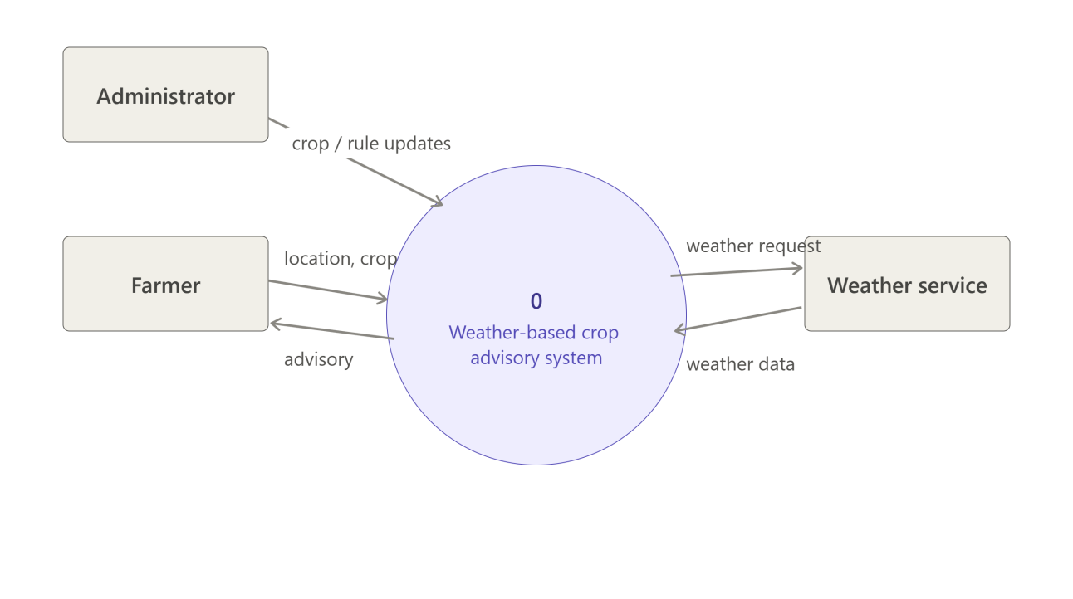
Figure B-1. Level 0 context data-flow diagram.
B.2 Data Flow Diagram – Level 1
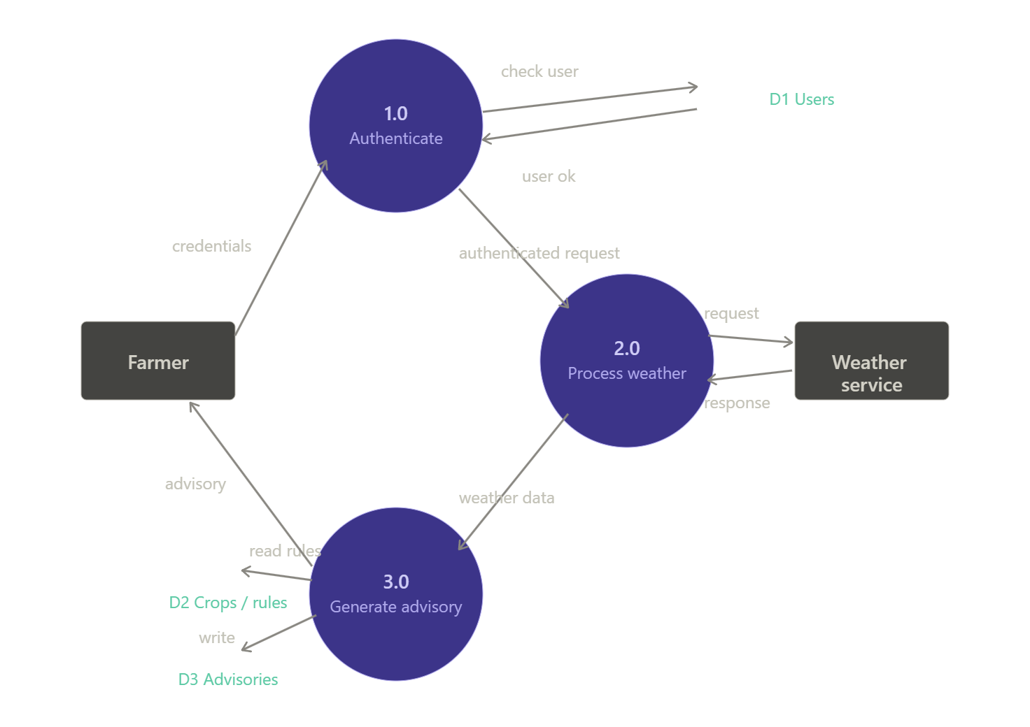
Figure B-2. Level 1 data-flow diagram.
B.3 Advisory Rule Table
Rule ID | Weather Condition | Crop/Farm Action | Severity
R01 | High probability of rain | Consider postponing irrigation if immediate watering is not required. | High
R02 | Unsuitable/strong wind | Avoid pesticide or fertilizer spraying during unsuitable wind. | High
R03 | Very high temperature | Check soil moisture and irrigation needs more frequently. | Medium
R04 | High humidity with wet conditions | Increase attention to weather-related crop risk. | Medium
R05 | Weather data unavailable | Show data unavailable; do not create weather-based advice. | High

B.4 Use Case Model
Farmer: register/login, set location, select crop, view weather, receive advisory, view alerts. Administrator: manage crops and advisory rules.
B.5 Class Model
Core classes: User, Crop, Location, WeatherData, AdvisoryRule and Advisory, with relationships supporting authentication, weather processing and advisory generation.
B.6 Activity and Sequence Models
Main activity: Login → Select Location → Select Crop → Fetch Weather → Evaluate Rules → Display Weather and Advisory. Main sequence: Farmer → Frontend → Backend → Weather API → Backend/Advisory Engine → Frontend.
B.7 ER, Component and Deployment Models
ER entities include User, Crop, Location, WeatherData, AdvisoryRule and Advisory. Components include Farmer UI, Backend API, Advisory Engine, Database and Weather Service. Deployment consists of a user device, application server, database and external weather service.
Appendix C: To Be Determined List
TBD ID | Item | Status
TBD-01 | Final weather-service provider/API plan | To be decided during implementation.
TBD-02 | Final hosting environment | To be decided during implementation.

